Tutorial Week 5-6
This weeks tutorial will cover Knowledge representation and reasoning. Note that Week 6 will be career week and there are no lectures or tutorials.
- Define in your own words the following terms: Logic, inference, model, satisfiability, validity, completeness, entailment, propositional logic, first-order logic, resolution, existential/universal quantification, forward/backward chaining, declarative vs procedural.

Logic: A formal system for representing and reasoning about knowledge
Inference: The process of deriving new sentences from old ones
Model: An assignment of truth values to propositional symbols that makes a sentence true
Satisfiability: A sentence is satisfiable if it is true in some model
Validity: A sentence is valid if it is true in all models
Completeness: A property of inference procedures that can derive any sentence that is entailed by the knowledge base
Entailment: A logical relationship between sentences where one sentence follows logically from another Propositional logic: A simple logical language using propositional symbols and logical connectives First-order logic: A more expressive logical language that includes objects, relations, and quantifiers Resolution: A complete inference procedure for propositional and first-order logic based on proof by contradiction
Existential quantification: A logical construct asserting that a property holds for at least one object in the domain
Universal quantification: A logical construct asserting that a property holds for all objects in the domain Forward chaining: An inference method that starts with known facts and applies rules to derive new facts Backward chaining: An inference method that starts with a goal and works backwards to find supporting facts Declarative vs procedural: Declarative knowledge represents facts about the world, while procedural knowledge represents how to do things

- Convert the following set of sentences to clausal form./
S1: E ⇒ D.
S2: C ∧ F ⇒ ￢B. S3: A ⇔ (B ∨ E).
solutions
S2: (¬E ∨ D).
S3: (¬C ∨ ¬F ∨ ¬B).
S1: (¬A ∨ B ∨ E) ∧ (¬B ∨ A) ∧ (¬E ∨ A).

- Resolution.

Consider the following sentence:
[(Study ⇒ Pass) ∨ (Persistence ⇒ Pass)] ⇒ [(Study ∧ Persistence) ⇒ Pass]

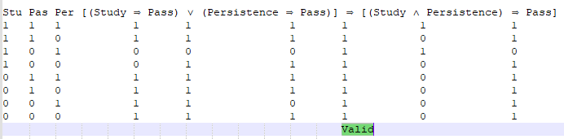
  - Use truth tables to determine whether this sentence is valid, satisfiable (but not valid), or unsatisfiable.
  - Convert the left-hand and right-hand sides of the main implication into CNF, showing each step, and explain how the results confirm your answer to (a)
For the left-hand side we have:
(Study ⇒ Pass) ∨ (Persistence ⇒ Pass) (¬Study ∨ Pass) ∨ (¬Persistence ∨ Pass)
(¬Study ∨ Pass ∨ ¬Persistence ∨ Pass) (¬Study ∨ ¬Persistence ∨ Pass)
and for the right-hand side we have (Study ∧ Persistence) ⇒ Pass
¬(Study ∧ Persistence) ∨ Pass (¬Study ∨ ¬Persistence) ∨ Pass (¬Study ∨ ¬Persistence ∨ Pass)
The two sides are identical in CNF, and hence the original sentence is of the form P ⇒ P, which is valid for any P.
  - Prove your answer to (a) using resolution.

To prove that a sentence is valid, prove that its negation is unsatisfiable. I.e., negate it, convert to CNF, use resolution to prove a contradiction.
¬[[(Study ⇒ Pass) ∨ (Persistence ⇒ Pass)] ⇒ [(Study ∧ Persistence) ⇒ Pass]] [(Study ⇒ Pass) ∨ (Persistence ⇒ Pass)] ∧ ¬[(Study ∧ Persistence) ⇒ Pass] (¬Study ∨ ¬Persistence ∨ Pass) ∧ Study ∧ Persistence ∧ ¬Pass
Each of the three unit clauses resolves in turn against the first clause, giving an empty clause. (¬Persistence ∨ Pass) ;by resolving (¬Study ∨ ¬Persistence ∨ Pass) with Study
Pass ;by resolving (¬Persistence ∨ Pass) with Persistence empty clause ;by resolving (Pass) with ¬Pass

  - Is there a contradiction in the clauses of question 5?
Can not derive a contradiction.

